***Dt : 7/11/2022***

***Java Collection<E> Framework(JCF):***

***define collection?(General definition)***

***=>The process of grouping elements together is known as collection.***

***define data structure?***

***=>The process of organizing elements in proper Structure is known as***

***data structure.***

***\*imp***

***define Collection<E>?(Library Component)***

***=>Collection<E> is an interface from java.util package and which is root***

***of Java Collection Framework(JCF).***

***=>Collection<E> is extented into the following Sub-Interfaces:***

***1.Set<E>***

***2.List<E>***

***3.Queue<e>***

***Hierarchy of Collection<E>:***

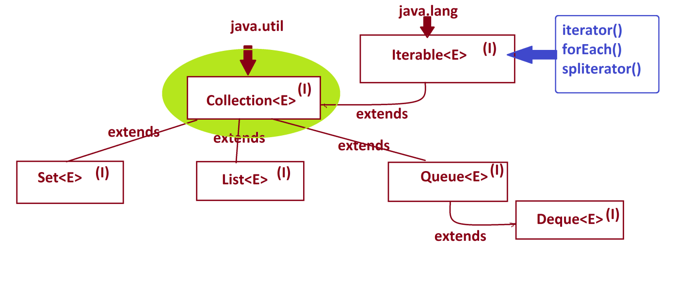

***-----------------------------------------------------------***

***define Generic Programming components?***

***=>The programming components which are ready to accept any type of data***

***are known as Generic Programming Components.***

***=>The following are some important generic programming components:***

***1.Generic Types***

***2.Generic Methods***

***3.Generic Classes***

***4.Generic Interfaces***

***1.Generic Types:***

***=>The types which are ready to accept any type of data are known as***

***Generic Types***

***T - Type***

***E - Element***

***K - Key***

***V - Value***

***2.Generic Methods:***

***=>The methods which are ready to accept any type of data as parameters***

***are known as Generic Methods***

***syntax:***

***<T>return_type method_name(T)***

***{***

***//method_body***

***}***

***3.Generic Classes:***

***=>The class objects which are ready to hold unlimited objects and any***

***type of Objects,are known as Generic Classes***

***syntax:***

***class Class_name<T>***

***{***

***//Class_body***

***}***

***4.Generic Interfaces:***

***=>The Interfaces which are extented into Generic Classes are known as***

***Generic Interfaces.***

***syntax:***

***interface Interface_name<T>***

***{***

***//Interface_body***

***}***

***=====================================================================***

***define Framework?***

***=>The structure which is ready constructed and available for application***

***development is known as Framework.***

***Diagram:***

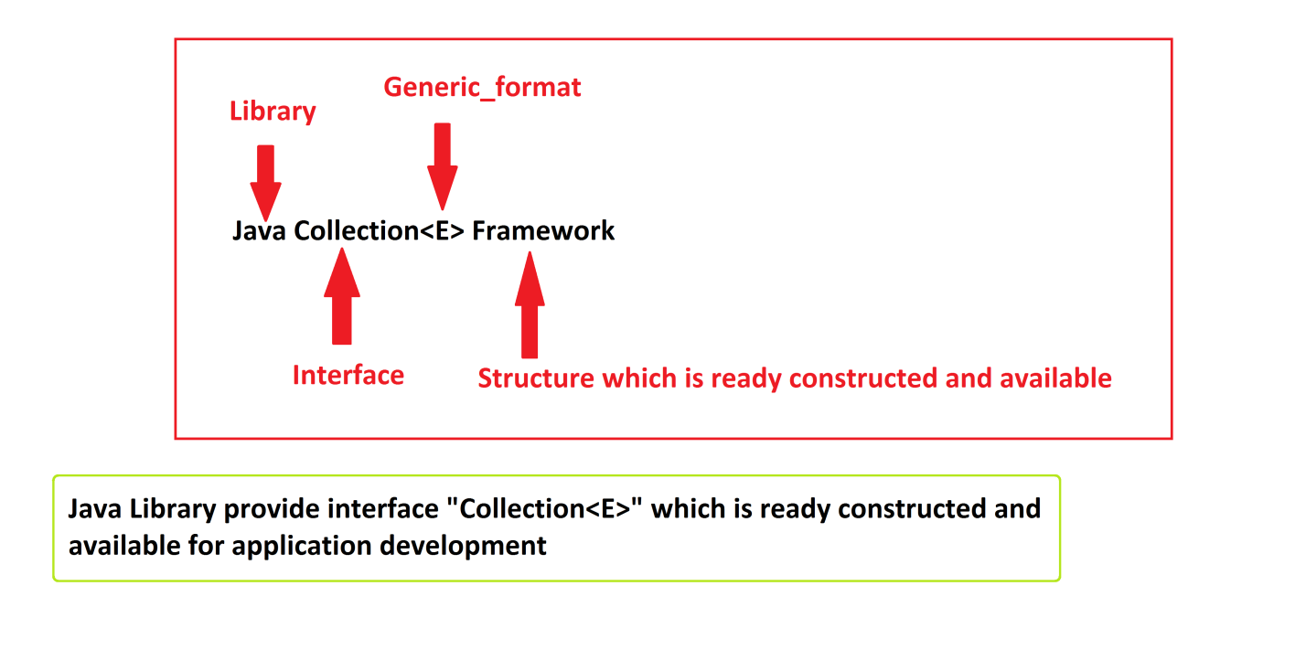

***====================================================================***

***\*imp***

***Complete Structure of Collection<E>:***



